COAST GUARD LICENSE APPLICATION FORMS OUPV REQUIREMENTS CHECKLIST
Beginning January 26, 2026, the National Maritime Center (hereafter known as the NMC) will require applicants to use the Application Submission and Additional Information Portal (ASAP), a website through the NMC, to submit applications for the United States Coast Guard (hereafter known as USCG) Merchant Mariner licenses. The application packet must be complete before starting your submission, as the NMC will no longer accept partial submissions.
Go to https://www.dco.uscg.mil/national_maritime_center/ to view the ASAP Tutorial.
ALL applicants must use their names as listed on their government-issued identification.

- APPLICATION: A completed USCG Application for Merchant Mariner Credential (MMC) (CG-719B) must be filled out in ink or typed. You may use the attached application in this packet. Your application package must be submitted to the NMC by scanning and submitting through the ASAP portal. NOTICE: The Application (CG-719B), the Medical Certificate (CG-719K), and supporting documentation are submitted through ASAP in separate sections.

- The application will require a reference number (Section I, 2b). Since you are a new applicant, you will LEAVE THIS BLOCK BLANK (EFF. 1.27.24). For further assistance, please go to www.uscg.mil/nmc to watch a video on how to complete the application.

KEEP COPIES OF ALL PAPERWORK YOU SUBMIT TO THE COAST GUARD!
- TRANSPORTATION WORKERS IDENTIFICATION CARD (TWIC): You must FIRST apply for the TWIC online at TWIC.gov before submitting your paperwork to the USGC for your license. When submitting your paperwork to the USCG, you must provide evidence that you either hold a valid TWIC or have applied for a TWIC.

- You must identify as a merchant mariner by selecting 'Merchant Mariner' as your occupation when applying for your TWIC.
- Proof of identity will be verified by TSA when applying for your TWIC.
- Fingerprinting: USCG licensing requirements for fingerprinting will be satisfied when you complete the TWIC application process.
- Proof of Identity and your fingerprints will be electronically forwarded to the USCG.

- PHYSICAL: An Application for Medical Certificate (CG-719K) must have been completed within the last 12 months of applying for the license. Follow the instructions on the form completely. This application is to be submitted on ASAP at the same time that you submit your MMC application.

- ADULT FIRST AID/CPR-AED: First-time applicants must provide a document from the organization [American Red Cross (ARC), American Heart Association (AHA)] where the course was taught. The AHA issues a certificate that includes a USCG/NMC course approval code, while ARC does not. The application will be delayed if this documentation is not included. The "little card" the organization issues is no longer acceptable. It must be the organization document. If you need a sample, see our website under “Forms”.

- DRUG TEST: Drug Test results must be dated within 6 months of application filing. Membership verification for the random drug screening program must be presented when the USCG boards your vessel for inspection.

- SEA SERVICE FORM(s):
-Boats you own or have owned: Proof of ownership must accompany each Sea Service form.
-Boats not owned: The owner of the boat or a USCG-licensed owner/operator must sign the Sea Service form.

- OATH: Effective 2025, the oath IS NO LONGER REQUIRED. Page 4, Section IV, #5 of the application IS TO BE LEFT BLANK.

- FEES: The following information/instructions are effective January 19, 2025. A $100 evaluation/processing fee and a $45 issuance fee are required and must be paid via credit card, debit card, or bank account information using Pay.gov. Pay.gov is a secure service provided by the United States Department of the Treasury. All other forms of payment are no longer acceptable, and any attempt to use another payment type will delay the application

The Pay.gov website has many tabs to make many different types of payments to the government. It is recommended that you do the following:

1. Go to the USCG website https://www.dco.uscg.mil/nmc/fees/
2. Select the Pay.gov button:
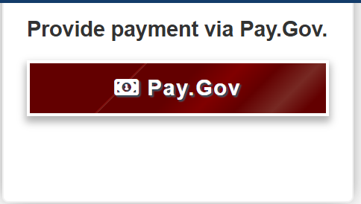
3. This will get you to the correct area of pay.gov.
Notice the title: USCG Merchant Mariner User Fee Payment:
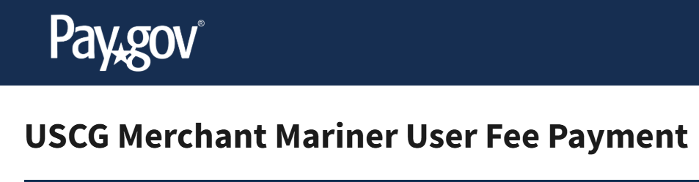

4. When you get to the section about what fees you are paying, select the following:
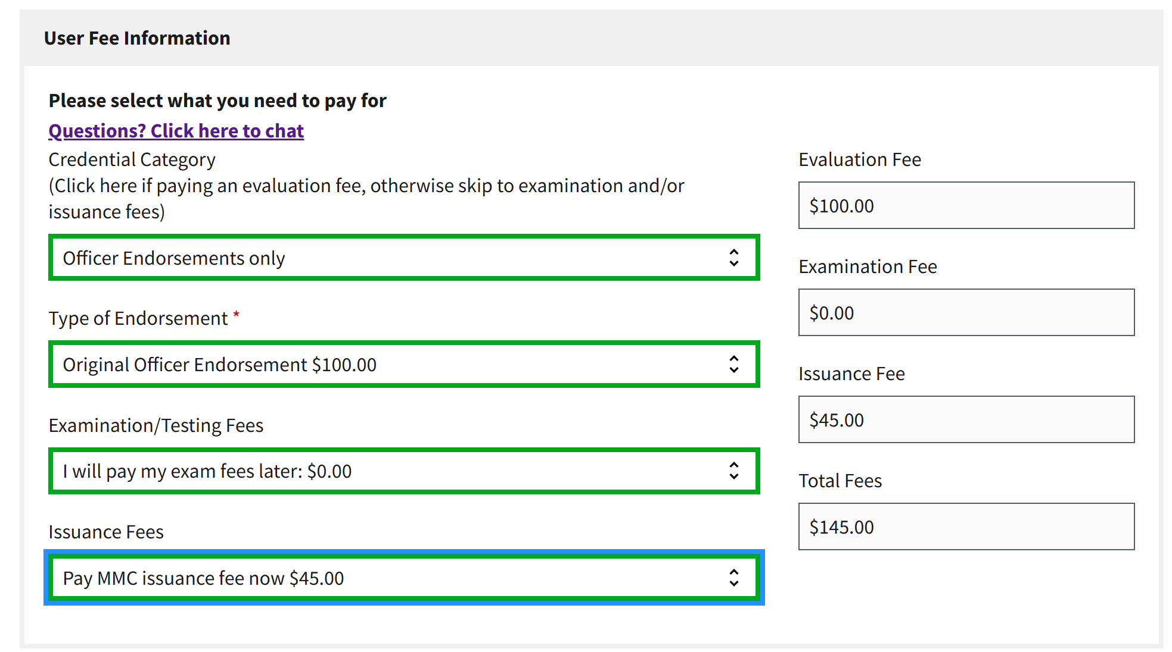

EFFECTIVE IMMEDIATELY – a Pay.Gov receipt must be included in your application packet. Any packet submitted without the Pay.Gov receipt will be rejected, which will delay the processing of your packet.

- Certificate of Training: Both sides of your TrueCourse Certificate of Training, printed on one sheet of paper, must accompany your application packet. Look for your email from TrueCourse with the Certificate attached.
REMEMBER, you have just ONE year from the date on your Certificate of Training to apply for your license.

For more information about the application process, contact the NMC Helpline at 1-888-427-5662, email IASKNMC@uscg.mil, or visit https://www.dco.uscg.mil/nmc/merchantmarinercredential/.

